That Mason Dixon Line.

I wanna go back to Dixie……..

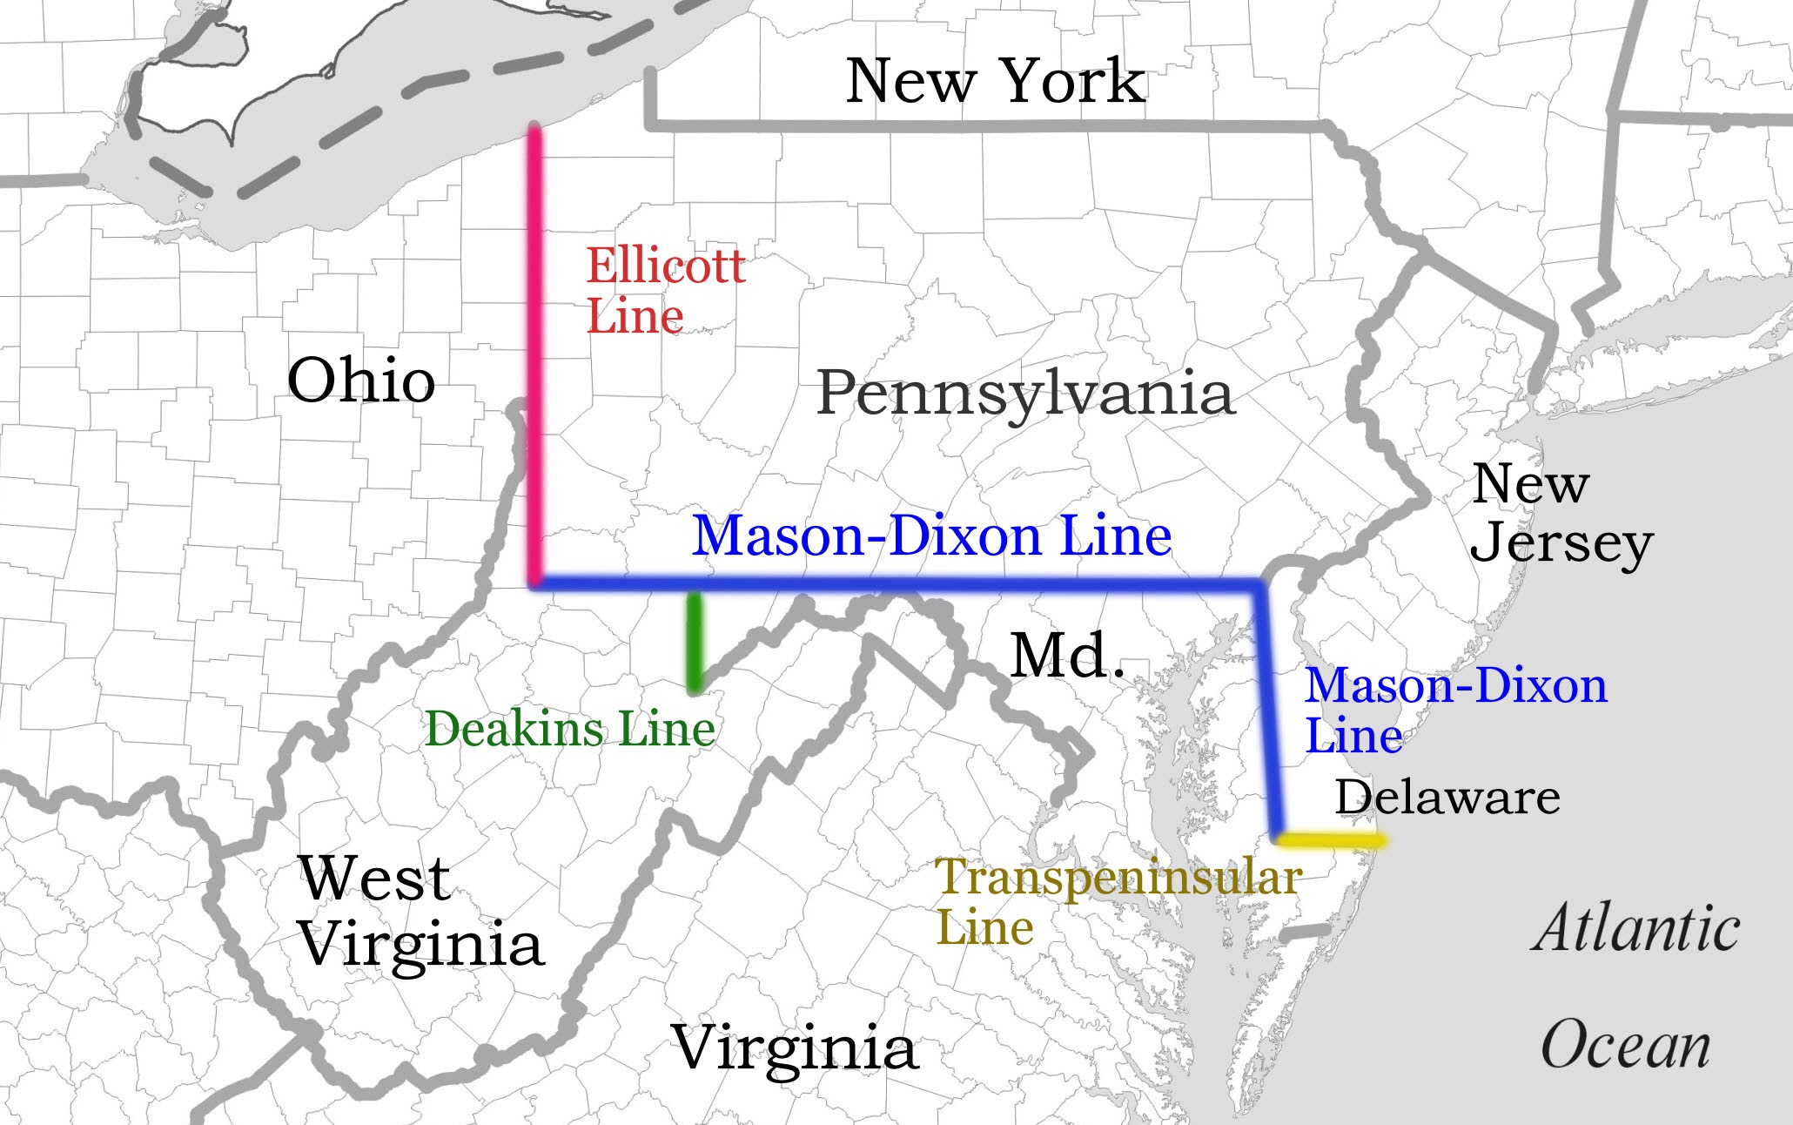
Map of Mason-Dixon Line and related borders
Below that Mason Dixon line
A line is the shortest distance between two points. This Euclidian analysis might be crowned with the initials Q.E.D. if it was a mathematical theorem. These initials stand which for Quod Erat Demonstrandum, translate as “which has been demonstrated”. The initials signify a mathematical or philosophical truth. The word “Demonstrandum” lies alongside the word representational. They imply a self contained, entity stamping an unquestionable argument. These types of Greek representation masquerading as truths held western art under its spell for over five centuries. My trajectory in art is in the opposite direction.

The Mason-Dixon line as visualised on a map has the similar engaging features of geometric simplicity and neatness to that of the theorem. The Mason Dixon line demarcates the border between Pennsylvania and Maryland, USA and lies on the 40th parallel in an east west direction with related linear markings running north and south. Tom Lehrer’s song from the nineteen fifties satirises the racial and political fall out from the decisions that were responsible for this division on the map. Ideas and notions associated with this line provide a vehicle with which to illuminate my practice and contemporary art.

Greek Euclidian thinking has pervaded western thinking since its rediscovery in Italy in the fourteenth century. It’s rules of geometry and the two dimensional concept of the line governed the whole sale introduction of one point perspective. This system of illusion is remarkable in its universality. It is claimed that it is the only system in art where a group of individual artists can produce an identical image when following its mathematical formulae. The hermetically sealed and apparently resolved solutions that one point perspective leave tell little of the human condition and strangles the contribution of the viewer.

Dieter Roth would be among many artists whose careers started in a representational way. Roth trained in graphic design in Switzerland and became a very proficient draughtsman and print maker. He started his professional career as a commercial artist. Following a visit to a Paul Klee exhibition in the early 1950s his practice abandoned the figurative and found meaning in experimentation across a vast range of media. They say that Roth drew with an axe. His line is more than mark making, they are gestural events that reflected so many aspects of his ebullient and enigmatic life. By putting Roth’s lines alongside that of Mason and Dixon as a duality, a synergy of meaning emerges that is greater than the sum of the discreet entities.

A line is a search for truth. Yet who's truth? Although the Mason Dixon line was surveyed to be along the fortieth parallel, the technology of the mid eighteenth century. The resulting line turned out to be some 17 degrees north of the parallel as measured by GPS with today’s technology. Previous surveying attempts at the line in the 1680s only had a tolerance of some 39 miles north or south. Multiple mark making that search for the edge seek an illusive truth that may not be there at all. It would be for the viewer to address the ambiguity.

The border between the two states that took over a hundred years to evolve could be juxtaposed to one of Roth’s lines executed in a fraction of a second. Although these unique qualities give them each their individual identities, they both possess a common borderland through which similar ideas could permeate. Roth’s energy and humour of his lines are in stark contrast to those of slavery, lynchings and civil war which were to become the signified hallmarks of the Mason Dixon line. These two conceptual beings intersect at the point of irony. The irony being, that a line drawn with a ruler should end up as the vehicle for the barbaric aspects of humanity while Roth’s line reflects life’s triumph. Lehrer’s brave song written and performed in the 50s when the civil rights movement was in its infancy weaves this satire and humour into this dark side of the human condition.

I want to be with southern gentlemen and put that white sheet on again.

Jeremiah Mason and Charles Dixon surveyed the boundary between the states in the 1760s. Starting at a one dimensional point, they marked the line with carved stones slabs at mile interval crossing rivers, hills farms and homes. The two dimensional topographical line thus morphed into a three dimensional one. This 3 D being could now be seen as an armature for a sculpture. As the lyrics of Tom Lehrer’s song imply, this armature becomes laden with socio-political and cultural meaning and difference with ultimately alarming results. If the original decisions made in an artwork are flawed then unexpected consequences can be expected. This would allude to experimentation. Experimentation was the prominent driver in Roth’s work through out his career. His chaotic installation of found objects and his sculptures with decaying and rotting food can still be seen in the galleries around Europe.

Waitin’ for the Robert E. Lee.
(It was never there on time).

Lehrer’s two lines bring in two interesting strands that bridge and at the same time illuminate art and life. The notions of time and chaos as implied in the lyrics are related themes that feed off each other. The time spent in the execution of Roth’s line is in marked contrast to that of the Mason and Dixon. The former produced decisive energy, the latter produced a laboured ambiguity. One required immediate energy that was captured as a historic event in the mark making; the other followed the artistic reading of the notion of entropy. The idea, purloined from the world of physics, is that energy in matter drains away and becomes absorbed into a generality. It is easier to lose energy than it is to be gained. Loss and gain are rates that are form a currency of time. Within the entropy of a line, lie multiple planes of meaning that include time which governs the outcome and the form of the whole. Rather than ask where is this time one should ask what is the time? It is not linear as in Lehrer’s riverboat. It can expand, contract, hide and interact within a structure. It may or may not be controllable. The energy required to maintain order in a line gradually decays. At a key tipping point in time, chaos can ensue than changes the shape, form and nature of the whole. The play with the unpredictability of time is evident and is used to an overt effect in Roth’s food sculptures.

Whuppin’ slaves and selling cotton

If the Mason Dixon Line is symbolic of slave states, the drivers and ideas behind slavery did not come to a close at the conclusion of the American Civil War. The idea that black people were inferior to white people through the myopic prism of racism was not restricted to the states below the line. Racism was spread throughout “the land of the brave and the free” in varying outcrops yet united in the malignancy of the message. Gilles Deleuze’s notion of the Rhizome is a vehicle that explores ideas and phenomena across the arts and philosophy. Like racism it is non structural. Rhizomes are botanical roots that can be unitary like a tree or multiple, near or distant, linked in some way yet independent and context driven. There is adaptation and metamorphosis that have non linear time characteristics. The multiplicity, adaptability and amophic nature of Rhizomic qualities are the contra logic prisms through which my practice aspires to.

Back in the the arms of my dear ol’ Mammy,
Her cookie’s lousy and her hands are clammy,

The frailty of deterministic structures appear to be associated with the dominance of the male mind set. In my research around the historic background for this text these playful lyrics of Lehrer’s are the only mention of the female hand in the unfolding events around the line. All the players in command of its associated catastrophic events were male. It appears to be a hall mark of male hierarchy to impose division, and to construct rules to perpetual the hegemony that excludes half the adult population. Lehrer’s sardonic line “want to speak with Southern Gentlemen” is given a new voice when viewed through this lens . And so it is in art, the female voice has only started to be heard in the closing decades of the last century.

There is no place like home.

This resolution of Lehrer’s satirical ditty is in contrast with the lack of complete closure associated with much of my work and that of contemporary art. The roots of the Rhizome undermine happy or sad endings. They do however provide planes of meaning that may or may not find a resting place. These planes are organic and flexible and allow air in the form of humanity to insinuate into the fabric of art to provide diverse philosophical and analytical viewpoints. The absence of a conclusion to this text is symbolic of the thresholds of ambiguity that gives art its dynamic.

…….to be continued.

Edited Bibliography:
Deleuze, G., Guattari, F. (1994) What is Philosophy. Verso: London.

Dobke, Dirk, (2004) Dieter Roth, Books and Mutiples. Thames and Hudson inc.: London.

Joyce, David. (1996) Euclid’s Elements. [Online]. Available from: http://aleph0.clarku.edu/~djoyce/java/elements/elements.html [Accessed: 1 August 2014].

Lehrer, T. (1953) I wanna go back to Dixie. Tom Lehrer Song Lyrics. [Online]. Available fromhttp://graeme.50webs.com/lehrer/index.htm [Accessed: 13 September 2014]

Roth, Bjorn., Flack,Robert (2014) Dieter Rot and Arnulf Rainer-Collaborations. Snoeck Verlagsgesellschaft: Koln.

The Tom Lehrer Wisdom Channel. (2012) I wanna go back to Dixie. YouTube. [Video]. 3rd April. Available from: http://www.youtube.com/watch?v=I7CJovhhVq8 [Accessed: 13 September 2014].

University of Delaware. (1996) A Brief history of the Mason-Dixon Line. Available from:http://www.udel.edu/johnmack/mason_dixon/ [Accessed 22 July 2014].

Exploretheline.com. (2014) Mason-Dixon Line Western Crossings. [Online]. Available from: https://www.google.co.uk/search?q=mason+dixon+line&espv=2&biw=1600&bih=739&source=lnms&tbm=isch&sa=X&ei=eT9ZVNeAC4H_sASZtICICQ&sqi=2&ved=0CAYQ_AUoAQ#facrc=_&imgdii=_&imgrc=M0XTxnhP4ht71M%253A%3BKMUZTxeokN-3_M%3Bhttp%253A%252F%252Fwww.exploretheline.com%252Fimages%252Flinemap.jpg%3Bhttp%253A%252F%252Fwww.exploretheline.com%252F%3B2060%3B1292
[Accessed: 4 November 2014].
James Norman

Mason-Dixon Line map , “Explore the line .com”.
Words from the lyrics of Tom Lehrer’s song.I wanna go back to Dixie. Lyrics can be found [Online] http://graeme.50webs.com/lehrer/dixie.htm Full performance of the song can be found on a 1967 film clip recorded in Copenhagen, [Online] http://www.youtube.com/watch?v=I7CJovhhVq8
Euclid’s theorems see Euclids Elements [Online]
Lucid accounts of the history of Mason-Dixon can be found [Online]http://pabook.libraries.psu.edu/palitmap/MasonDixon.html or at the University of Delaware’s site [Online A Brief history of the Mason-Dixon Line. Available from:http://www.udel.edu/johnmack/mason_dixon/

